Issue 1.0: Jan 2020

IHMCL - Request for Proposal (RFP) For Selection of Vendor for Design, Develop, Supply, Test, Install, Commission, Configure, System Integration, and Operations and Maintenance of Proprietary Toll Management System (PTMS)

Proprietary Notice
This document contains information that is proprietary and confidential to NEC Technologies India Private Limited, which shall not be disclosed outside Dubai Port World (DPW) company limited, transmitted or duplicated, used in whole or in part for any purpose other than its intended purpose. Any use or disclosure in whole or in part of this information without express written permission of NEC Technologies India Private Limited is prohibited. Any company and product names mentioned are used for identification purposes only and may be trademarks of their respective owners.
© Copyright 2019 - NEC Technologies India Private Limited (NECTI).

Security Notice
The information contained herein is proprietary to NEC TECHNOLOGIES INDIA PRIVATE LIMITED and may not be used, reproduced or disclosed to others except as specifically permitted in writing by NEC TECHNOLOGIES INDIA PRIVATE LIMITED. The recipient of this document, by its retention and use, agrees to protect the same and the information contained therein from loss or theft.

NEC Code of Conduct
We, in our dealings, are self-regulated by a code of conduct as enshrined in the “NEC Code of Conduct”. We request your support in helping us adhere to the code in letter and spirit. We request that any violation or potential violation of the code by any person be promptly brought to the notice of the Local Ethics Counsellor or the Principal Ethics Counsellor or the CEO of NECTI. All communication received in this regard will be treated and kept as confidential.

Confidentiality Notice
Both parties undertake to hold information shared in the course of this business relationship in strictest confidence and undertakes not to disclose such information, either in whole or in part, to any person other than those of its officers, employees, and agents who need to know the confidential information for the purpose explicitly authorized for.
Confidential Information shall mean any information disclosed by one party (hereinafter the “Disclosing Party”) to the other (hereinafter the “Receiving Party”), either directly or indirectly, in writing, by inspection of tangible objects (including, without limitation, documents, prototypes, samples, media, documentation, discs and code). Confidential Information shall include, without limitation, documents, any materials, trade secrets, know-how, formulae, processes, algorithms, ideas strategies, inventions, data, network configurations, system architecture, designs, flow charts, drawings, proprietary information, business and marketing plans, financial and operational information, and all other non-public information, material or data relating to the current and /or future business and operations of the Disclosing Party and any analysis, compilations, studies, summaries, extracts or other documentation prepared by the Receiving Party based on information disclosed by the Disclosing Party. Confidential Information may also include information disclosed to the Receiving Party by third parties on behalf of the Disclosing Party.
Table of Contents
1.1. OVERVIEW 4
1.2. System Architecture and System Flow 5
1.3. Toll Management System and Linked Modules 6
1.4. Payment Methods allowed for Toll Collection 6
1.5. System Performance 7
1.6. Salient Features 7
1.7. Architectural Details of the system 7
1.8. Interfaces for System Integration with hardware and other Systems 9
1.9. Reports in the System 9
1.10. Disaster Management 9
1.11. APPLICATION MAINTENANCE 10

OVERVIEW
Toll Collection and Management System will be a system that facilitates toll collection and operations at Plazas including Centralized Monitoring and Control System. The system already has a wide range of hardware and ETC systems integrated and successfully running at more than 3 dozen plazas.

The system is easy-to-use and can be easily localized and controlled from a centralized location. Since the system is highly scalable, n number of plazas and lanes can be integrated in it. The system provides all the tools and utilities to manage toll collection, monitoring, auditing, and checking and fixing of hardware and equipment failures. The system also provides real-time data as well as several reports covering every aspect on the system. The system comes with a wide range of hardware’s already integrated including RFID readers, way in motion (WIMs), static wave bridge, cameras, bar code scanners, profilers, smart card readers, document scanners, networking equipment, AVC systems, controllers, handheld devices, etc. of different makes and models. The system is already interfaced with VAHAN, SARATHI, MPRDC databases, Central Clearing Houses (CCH), banks, etc. Since the system is modular, new hardware, systems and functionalities can be easily integrated. The system also provides error logging and escalation system with alerts through different modes. The system is equipped to handle RFID based ETC transactions, cash transactions, card-based transactions and other type of transactions in volumes and high speed.

The system covers and has provision to automate every aspect of the system be it toll collection, control of movement of vehicles in the lane, defining fare and penalties, detection of failure of equipment, backup, till transfer of the amount in banks/ESCROW accounts. It also provides facility to define workflows that can be uniformly implemented across toll plazas and systems. Graphical User Interface (GUI) from the level of lane and plaza, till centralized monitoring system can be easily customized to suit various hardware’s, mobile devices and screen sizes as well as cultures. There is help available on screen as well as support staff, call center and a dedicated team of professionals in various regions to provide support wherever required.

We have integrated a centralized and sub-centralized dashboard with different access levels to monitor and control plazas including fares, access control, revenue, HR and traffic-related details. At lower level, this control is also provided at plaza level to manage that specific plaza. There is also a disaster management control in place.

System Architecture and System Flow
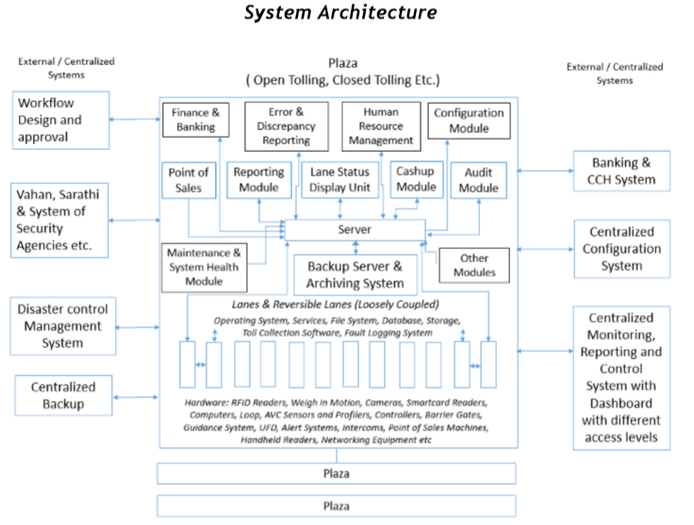

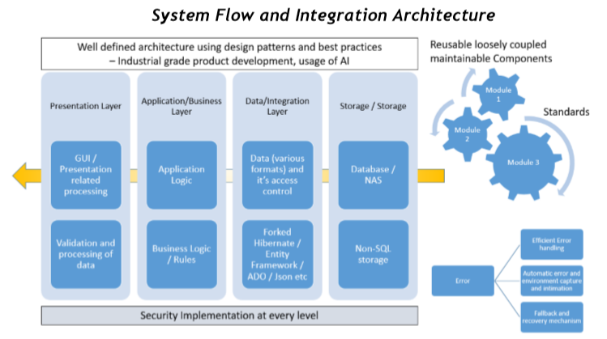

The system consist of Toll Collection System comprises of:
- Centralized Monitoring and Control System: Local and Centralized level
- Finance and Accounts Module: Fare, Penalties, Discount & Taxes: The module provides facility to input or pull details of fare for calculation at the toll plaza. It shall also have provisions to calculate penalties, additional charges that may be levied at a vehicle for over-speeding, overloads, taxes etc. The module shall also have features related to accounts reconciliation and support refunds related requirements.
- Integration Module: This module provides details regarding integration with various internal and external systems required within the sub-System Resource Management / Employee Module: It captures various details available to employee regarding application processing and reports generation.
- Control and Assistive Modules
- Privilege Control and Maintenance Module: This module highlights details regarding system configuration and metadata updates that shall be available to system administrators, or to other authorized users.
- System in Lane for Toll Collection: • Electronically processed transaction • Changes the signals and displays based on operator and sensor input • Automatically classifies vehicles for comparison with the operator classification • Records each transaction and sends it to the central database of Plaza • Keeps a running tally of receipts for each operator • Monitors activity in each lane • Maintains a record of each vehicle that has passed through the system • Generates a variety of reports on system operations for management purposes.
- Audit Module
- Configuration Module
- Reporting Module comprises of reports to cover almost all the aspects of toll collection and related management system including downtime reports, revenue reports, traffic details reports, ETC collection etc.
- Lane Status Display tool
- Discrepancy Identification and Fixing tool
- Automatic Vehicle Classification System
- Point of Sales
- Cash up Module
- Assets management Module

Toll Management System and Linked Modules
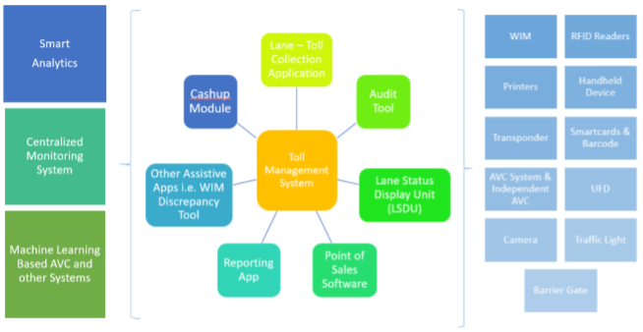

Payment Methods allowed for Toll Collection
Some of the payment methods allowed in the system for Toll Collection are as follows:
- RFID Tags based, FASTag
- Mobile Payments
- Bank Transfers
- Debit Cards
- Credit Cards
- E-wallets
- Prepaid Cards
- NFC Cards
- QR & Barcodes
- Direct Deposit
- Cash
- Cheque
- Bulk payments

System Performance
The System has throughput for the vehicles exceeding the following criteria:
- FASTag / RFID Tag based: 1200 vehicles per hour
- Cash: 240 vehicles per hour
- Smart card (T&G): 600 vehicles per hour
- Validation: 600 vehicles per hour

Salient Features

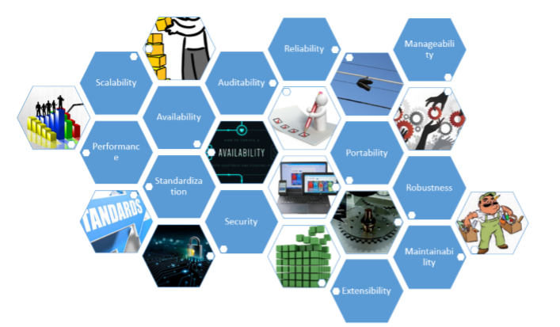

Auditable | High Performance | Maintainable | Highly Available
Standardized | Secure | Extensible | Robust
Adaptable | Portable | Integrate | Scalable

Architectural Details of the system
- Software Development using Design Patterns for robust, quick, reusable and reliable development
- Development using skins
- Dr. Watson type error handling, logging and reporting
- Scalability by separation of layers and modification of architecture
- Provision of Localization & Globalization
- License control for features, validity etc.
- High Uptime
- Quick and automated backup
- Modifiable business logic layer
- Database independent / less dependency on backend medium of storage
- Data Recovery – Automated and Semi automated
- Controlled exposure of resources through web services and endpoints
- Obfuscation and Compression
- Multi tenancy
- Multi device portability
- Close tolling, Open Tolling, Distance Based
- High speed ETC System
- Facility to integrate cloud, Distributed and Clustered Storage etc
- Loosely Coupled System – Failure of one component doesn’t affect other
- Inventories, logs, manuals, technical design, standards, technical notes and records
- Disaster Recovery
- Data integrity – No data mismatch in reports
- Higher AVC accuracy
- Effective reports to give complete overview of the system
- Use of Industry standards – Easy integration of devices and other systems
- User friendly and Aesthetic Graphical user interface (GUI)
- Asynchronous Communication – On demand and capacity communication
- Execution Speed
- Security
- Latest features prevalent in toll collection field
- Automated installer with dependency checks
- Creation of knowledgebase
- Addition of new equipment and features
- API for pulling data for Analytics
- Segregation of business and presentation layer
- Component based implementation
- Robust error capturing and handling
- Documentation – User manual, repository, technical manual
- Strict Version Control
- Small footprint
- Extraction of information and predictions through Analytics
- Inbuilt fallback mechanism in case failure of devices, software’s, data, and other artifacts
- Caching
- Security (System and Data Level)
- Distributed Architecture
- Plug n Play - Auto Detection of devices and other artifacts
- Dynamic Creation of Reports – Self defined templates

Interfaces for System Integration with hardware and other Systems
The systems interface other systems through:
- Standardized Protocols & Plug and Play System
- Software Development Kits (SDKs)
- Application Programming Interfaces (APIs)
- Database Access
- FTPs and SFTPs
- Sockets
- File System
- Queues
- Web Services etc.

Reports in the System
There are huge number of reports in the system to manage every aspect, however, some of the reports are as follows:
Multiplaza and Project Reports | Updates and Modification Reports
Audit Trail Reports:  - Error and Warning Logs  - System and Database Change Reports  - Cancellation Reports | NHAI Reports  - Monthly Fees Statement  - Schedule M & N Reports  - Weekly Reports  - PCU Report
Control Room Reports  - Violation Report  - Traffic Report  - Revenue Reports  - Trip based Reports  - AVC Accuracy Details  - WIM Related Reports  - Overload Reports | AVC Reports  - AVC Accuracy Details  - AVC Pattern Details
Transaction Reports  - Revenue Report  - Shift Details  - Traffic and Revenue Report  - Blacklist Details  - ETC Traffic Details  - Reconciliation Report  - Violation Reports  - Repost Reports | POS Reports  - PoS Sales Recharge Report  - Revenue Report  - PoS Transaction Report  - PoS Revenue for Credit  - PoS Revenue for E-wallets
Cash Up Report | Bleed off Reports
ETC Reports - Tag Detail Report and Revenue Details

Disaster Management
- The company has excellent track record worldwide to provide different kinds of IT services including Disaster Management.
- We have regional centers headed by regional heads as well as adequate manpower in each region and capacity to respond within the laid down timeframe.
- For disaster management we have specific guidelines, standard operating procedures and timelines defined that comply with the requirement.
- The team of experts is equipped with tools and knowledge related to restoration of site and system in case of any disaster.
- The team has different levels of support and escalations that happen automatically once the criteria is not fulfilled or response is not provided.
- Apart from providing response in case of a disaster the team also takes proactive approach by continuously monitoring the site through automated tools at their control center as well as through team at site.
- In the event of any disaster the system will be equipped with software, hardware and the functionality to restore data (Inclusive of images, videos, files, database, data) along with the specifications, configuration details and software components required at each plaza. In the event of any failure all the data will be safe and be restored once the physical infrastructure and connectivity at plaza will allow.
- The data can be transported in real time or through other means to plaza or can be downloaded automatically and restored.
- Our teams keep evaluating latest technologies and incorporate them to ensure high uptime as well as secure and highly available systems.
- There is a separate team that is responsible for carrying out vulnerability test, bug identification and threat assessment on daily basis and suggestions given by it are incorporated on priority across all the plazas in minimum possible time and in line with the MPSS and FRS, by adopting the required and well defined laid down procedures i.e. declarations, legal aspects, standard operating procedures.
- Real time backup management system and offline data backup system at plaza level
- Restoration Control for Data inclusive of control over duration, compression, channels, protocols, complexity, levels, software, configuration and components
- The Centralized Storage Control and Restoration Systems will have their own disaster management plan and its data will be mirrored securely at systems available in different zones with load control. It can be separately tuned to work for different protocols, channels, encryption, security and control system.
The System has mainly 4 components and other subcomponents:
- Centralized Storage System and Infrastructure with disaster management of its own for data, configuration and other components received for and from all the plazas
- Centralized Control and archiving system
- Real time backup management system and offline data backup system at plaza level
- Restoration Control for Data inclusive of control over duration, compression, channels, protocols, complexity, levels, software, configuration and components
- The Centralized Storage Control and Restoration Systems will have their own disaster management plan and its data will be mirrored securely at systems available in different zones with load control. It can be separately tuned to work for different protocols, channels, encryption, security and control system.

APPLICATION MAINTENANCE
- With the change in technology, policies, requirement, rates and flow, there is need to modify/configure the software and system so that it can be accommodated. In this regard, Change Request (CR) is raised and implementation is carried out.
- We adopt the following steps to achieve the same:
  - Change Request is raised
  - Impact analysis is done
  - Shortlisting of the technology (if required)
  - Report is shared (if required)
  - Approval is sought (if required)
  - Pilot Implementation is done (if required)
  - Time frame for implementation is shared (if required)
  - Implemented
  - Approval is sought for large scale implementation from the appropriate level (if required)
  - Logged in the repository with details and documents associated with it along with the tracker information.
  - Manuals and documents are updated
  - Training imparted (if required)
- The above-mentioned steps are completely automated and change request tracking facility is provided in the dashboard along with time consumed at each step from the time of raising the request till the delivery of the requirement.
- The dashboard also provides Key Performance Index (KPI) against each request, version information, details associated with it and history. There are different roles and levels available in the system for approval as well as to see the details of the Change Request.
- The trained staff always remains available to carry out the implementation, be it analysis, development, deployment, training or any other level.

